

INSTALLATION & CONFIGURATION

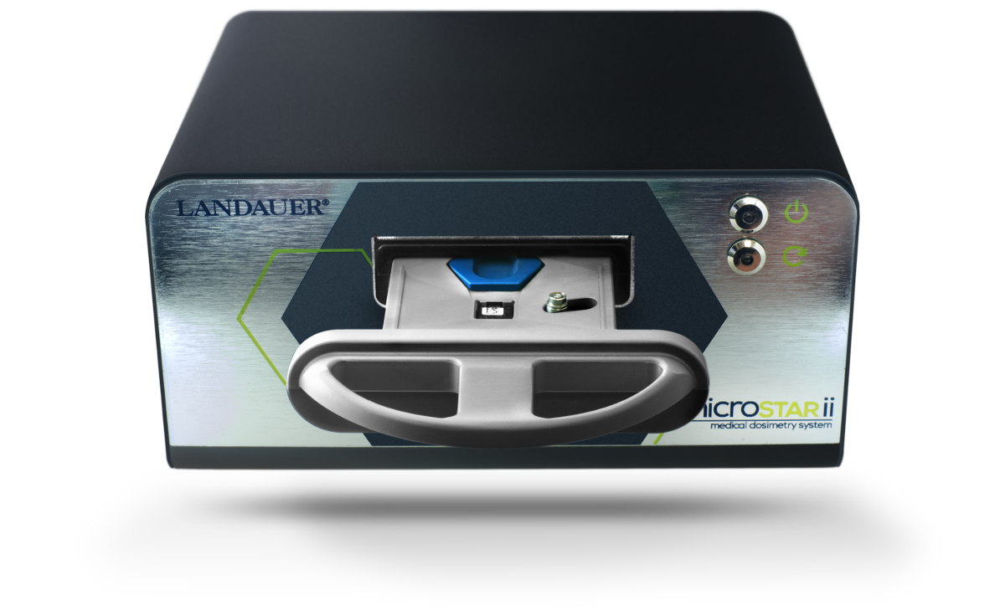


v2.0 | 02/15/2016
PROPRIETARY RIGHTS NOTICE
This guide is furnished under license only for the use and information of the licensee. It contains confidential and proprietary information belonging to LANDAUER, Inc.
As such, this guide may not be reprinted or redistributed to any third party without the written consent of LANDAUER, Inc.
Use of the contents of this installation guide for any purpose other than that for which it was provided is prohibited.
LANDAUER, Inc. does not warrant or guarantee the contents of this guide.
LANDAUER, nanoDot, and microSTARii are registered trademarks of LANDAUER, Inc. in the United States and other countries. All other company, product, and service names and brands are the trademarks or registered trademarks of their respective owners.

©2016 by LANDAUER, Inc.
All rights reserved.

Table of Contents
Chapter 1 Introduction 1
1.1 Limitations of Product Scope 2
1.2 Conventions and Standards 3
Chapter 2 Hardware Shipment 4
2.1 Parts List 4
2.2 Unpacking & Handling 6
Chapter 3 Reader Hardware Specifications & Design 7
Chapter 4 Hardware Installation 9
4.1 Installation Requirements 9
4.1.1 Environmental 9
4.1.2 Electrical 9
4.2 Physical Setup: Computer 10
4.3 Physical Setup: Reader 10
4.3.1 Install the Drawer 10
4.3.2 Connecting to Power Source 11
4.3.3 Connecting the Reader to the Computer 11
4.3.4 Verifying Connectivity 11
4.3.5 Connections Example 12
Chapter 5 Software Configuration 13
5.1 Logging In 13
5.2 Changing Admin Account Password 14
5.3 Connecting Reader 15
5.4 Creating User Accounts 16
Chapter 6 System Configuration 19
Chapter 7 Testing & Calibration 21
7.1 Performance Testing 23
7.1.1 Intrinsic Test: Reader QC Test 23
7.1.2 Reader Daily QC Test 25
7.2 Reader Calibration 27
7.2.1 Initial Calibration 27
7.2.2 Post-Calibration Quality Control Check 29
7.2.3 Custom Calibration 31
Chapter 8 Troubleshooting 32
8.1 Technical Support 32

Introduction
The microSTAR®ii Medical Dosimetry System is used as an independent secondary dose verification system that performs comprehensive measurement readings of the nanoDot™ Optically-Stimulated Luminescence (OSL) dosimeter. The system reads the dosimeter, performs analysis using calibration parameters and customer-specific configurations, and provides in-depth reporting for review. The system stores the data for reference and cumulative dosage records. It uses a compact Optical Engine with a high-powered Light-Emitting Diode (LED) and Pulsed Optically-Stimulated Luminescence (POSL) to provide a precise radiation dose measurement.

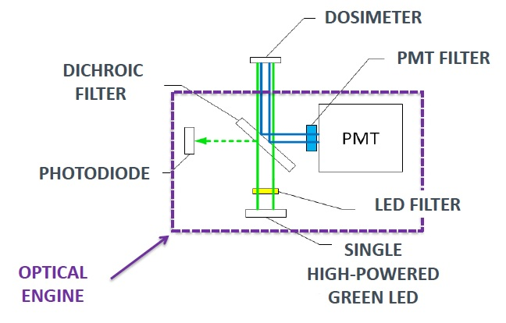
Figure 1-1: Optical Engine Components
The microSTARii Medical Dosimetry System includes both hardware and software components. The hardware is used to scan and read the nanoDot dosimeter. The software provides the tools necessary to manage the reader, view stored measurement data, generate reports, manage patient assignment, and manage inventory.
This guide contains detailed instructions on how to install and configure the microSTARii Medical Dosimetry System, including but not limited to:
- Reader Specifications & Design
- Reader and Computer Physical Setup
- Software Configuration
- Reader Verification
- Reader Calibration
This guide is for use with the standard system configuration (reader and LANDAUER-provided computer). For assistance with custom configurations, contact LANDAUER Technical Support (8.1 Technical Support).
Related documentation can be found at http://landauer.com/microstarii. This includes:
- microSTARii User Manual for detailed instructions on operations, advanced configuration, maintenance, and troubleshooting.
- Frequently Asked Questions for information about the system design, operations, and term definitions.
- microSTARii™ – A new system for medical dosimetry: Part I: Technology & Initial Performance a white paper that provides information on the design and performance.

Limitations of Product Scope
The microSTARii Medical Dosimetry System has been designed as a secondary dose verification system. The system should therefore only be employed as one of a number of tools in a program of quality assurance for the primary dose verification systems being used.
The results obtained with the microSTARii should not be used to guide direct patient care decisions. However, under certain specific conditions results obtained using the microSTARii Medical Dosimetry System can be cited and reported as a secondary verification of the primary systems in place used to predict or assess the radiation dose to patients resulting from diagnostic or therapeutic procedures.
The nanoDot dosimeter used in the microSTARii Medical Dosimetry System is manufactured as a single-use device. Due to the potential for changes in dosimeter performance with accumulating life-time dose, LANDAUER and its affiliates do not support reuse of the nanoDot dosimeter.
Customers who intentionally disregard these stated limitations of product scope assume full responsibility for any negative consequences resulting from any such use.
The user assumes full responsibility for implementing site-specific procedures to ensure correct patient identification, HIPAA-compliant management of patient Personally Identifiable Information (PII), dosimeter verification, and proper usage including: transport, handling, placement, and timely readout. It is strongly recommended that site-specific written Standard Operating Procedures be implemented prior to launching a Medical Dosimetry Program.

Conventions and Standards
The following symbols are used within this documentation to mark risks, warnings, and other information.
ISO 3864, No. B.3.6
Caution – Risk of Electrical Shock
ISO 3864, No. B.3.1
Caution – This symbol denotes information that could affect the equipment operation.
IEC 417, NO. 5019
Protective Conductor Terminal
| | IEC 417, NO. 5007 On (Supply)
 | IEC 417, No. 5008 Off (Supply)

Hardware Shipment

Parts List
The following items are included in the microSTARii shipment.
Parts & Materials
microSTARii Reader
microSTARii Reader Accessories
- Drawer
- Power Supply
- USB Cable
Standalone Computer (All-in-One or Laptop) with microSTARii Software Pre-Installed
Computer Accessories
- Power Cord
- Keyboard (if All-in-One)
- Mouse (if All-in-One)
Barcode Scanner
nanoDot Dosimeters
- 1 NIST-Traceable 80 kVp, Cs137, or Non-Standard Calibration Set (Calset) with Certificate
- 1 NIST-Traceable 80 kVp, Cs137, or Non-Standard Quality Control (QC) Set with Certificate
- 2 Consistency nanoDots
- Additional unexposed nanoDot dosimeters (Screened or General Purpose), if ordered
Related Documentation
- Factory Test Results Sheet
- Installation & Configuration Guide
- User Guide
- Related Field Service Bulletins
- Computer Support Documentation

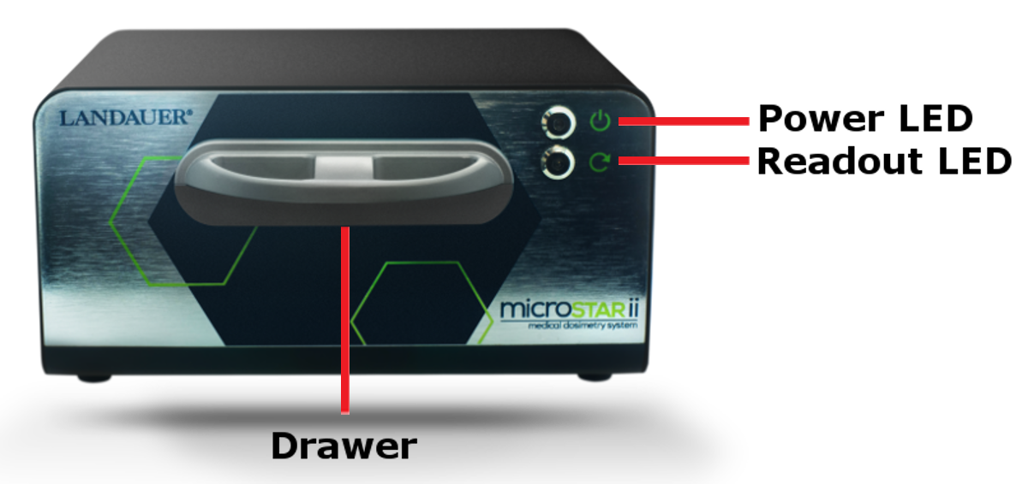
Figure 2-1: microSTARii Reader – Front
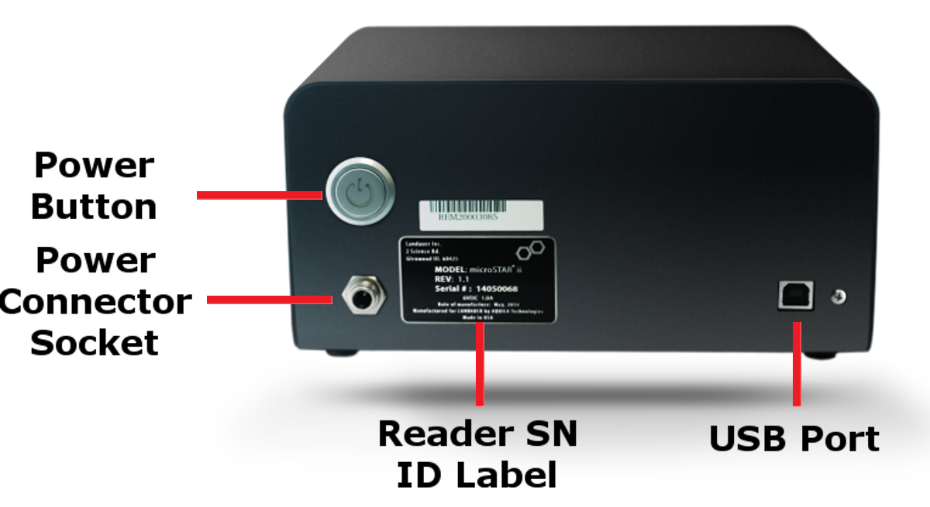
Figure 2-2: microSTARii Reader – Back
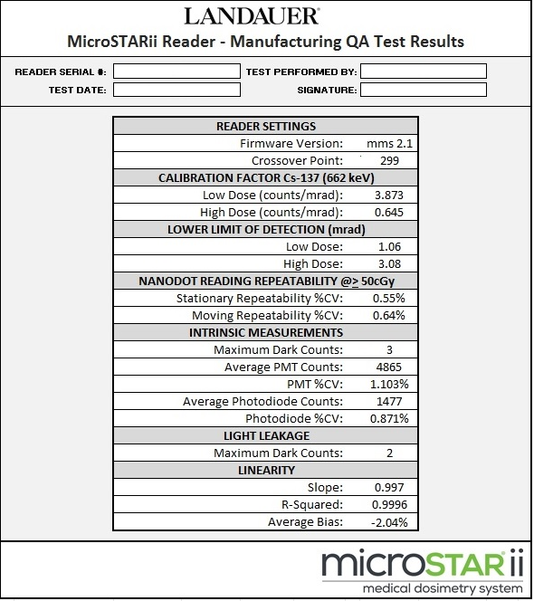
Figure 2-3: Sample microSTARii Reader Manufacturing QA Test Report
NOTE: If your reader is operating correctly and has not been damaged during shipment, its performance at installation should be comparable to that measured during manufacturing QA Testing. Note in particular the Low and High Dose calibration factors and the PMT and P-Diode average baseline values from your test sheet and compare with the results obtained during installation testing.

Unpacking & Handling
The parts should be unpacked in the lab or office where the microSTARii system will be operated. Unpack the system carefully as small parts, cables and nanoDot dosimeters are included with the shipment. Inspect the box for loose parts before beginning installation.
NOTE: It is strongly recommended that you save the packing material and boxes in the event that a reader needs to be returned for preventive maintenance or service at a later date.
microSTARii is carefully packed at the factory to minimize the possibility of damage during shipping. However, to ensure there has not been damage in transit, inspect the exterior and contents of the box for signs of damage or mishandling. If there is visible damage to the reader, computer, or accessories upon receipt, inform the shipping company and LANDAUER, Inc. immediately.

Reader Hardware Specifications & Design
The following subsections contain specification information for the microSTARii reader hardware.
Physical Specifications
Dimensions | - Depth: 6.01 in (152.7mm)  - Width: 8.13 in (206.7mm)  - Height: 4.06 in (103.3mm)
Weight | 5.14 lbs. (2.33 kg)
Enclosure Material | Metal case, powder coated
Connections | USB
Power | 6V, 1.0A
Operating Environment | 5°C to 40°C; < 70% Relative Humidity non-condensing; in stable conditions  NOTE: Extreme temperature fluctuations may impact performance.
Storage Environment | -20°C to 60°C; < 90% Relative Humidity non-condensing
Use Location | Indoor use only

Performance Specifications
Metric | Specification | Notes
Accuracy | ± 5.5% | Using screened nanoDots (k=2)
Repeatability | ≤ 1.0% | Coefficient of Variation; n=10, dose >50+ cGy
Lower Limit of Detection (LLD)
Strong Beam (Low Dose) | ≤ 3 mrad | Lower limits with freshly annealed blanks
Weak Beam (High Dose) | ≤ 20 mrad | Lower limits with freshly annealed blanks
Depletion
Strong Beam (Low Dose) | ≤ 0.60% | Percent depletion per read
Weak Beam (High Dose) | ≤ 0.07% | Percent depletion per read
Intrinsic Stability
Dark | ≤ 20 | Counts/Second
LED with Photodiode | ≤ 3.0% | Coefficient of variation computed across 10 consecutive measurement cycles
LED with Photomultiplier Tube | ≤ 3.0%
Light Leakage | ≤ 20 | Counts/Second

Hardware Installation
Use the information and instructions in the subsections to set up the computer and install the microSTARii reader and peripherals.
- Set up Computer & Connect Peripherals (4.2)
- Plug In Reader (4.3.1)
- Connect Reader (4.3.3)
- Verify Connectivity (4.3.4)

Installation Requirements

Environmental
microSTARii may be operated in most clinical environments that have a stable ambient temperature. For best results, it is recommended that the system be installed in a dedicated location on a stable surface away from direct sunlight.
NOTE: It is recommended that the nanoDot dosimeters be stored away from direct sunlight and fluorescent light when not in use.

Electrical
Before attempting to install the system, verify the wall socket that will be used is properly polarized and properly grounded. If possible, connect both the reader and the computer into a surge protection power strip and connect the power strip to the wall outlet.

Physical Setup: Computer
Equipment Needed
- Computer  - Accessories (if all-in-one): Mouse and Keyboard | - Barcode Scanner
Refer to the manufacturer’s User manual for PC setup and Operation.
- After setting up the PC according to the instructions provided by the manufacturer, turn on the PC.
- Connect accessories to the PC (i.e., mouse and keyboard)
- Connect the barcode scanner USB connector to any available USB port on the computer.
- Log on to the computer using the default logon credentials.
Default Logon Credentials | USERNAME: admin
Default Logon Credentials | PASSWORD: system
Note: The Windows password should be changed after initial log on. Ensure the updated credentials comply with organizational security policies.

Physical Setup: Reader
Equipment Needed
- Drawer  - Reader | - Power Supply  - USB Cord

Install the Drawer
To install the reader drawer follow the steps below:
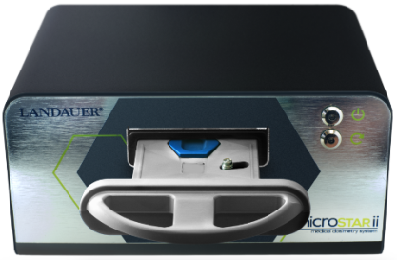
- Position the drawer with the nanoDot and ejector facing up (Figure 4-1).
- Slide the drawer into the reader.
WARNING: Improper insertion of the drawer can cause serious damage to the reader. Always insert the drawer using the orientation shown. Never force the drawer into the reader. To avoid damage to the optical engine, the drawer must be fully inserted before connecting the reader to a power source and turning the reader ON.

Figure 4-1: Correct Drawer Orientation

Connecting to Power Source
Figure 4-2: Connecting Reader Power
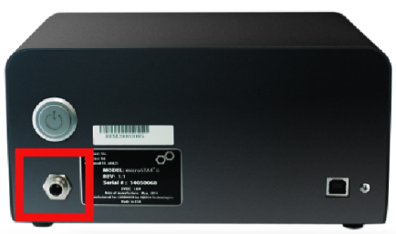
- Plug the reader power supply cord into the reader and screw down the connector.
- Plug the other end of the power supply cord into the power outlet. (The outlet must meet electrical requirements in 4.1.2.)

Connecting the Reader to the Computer
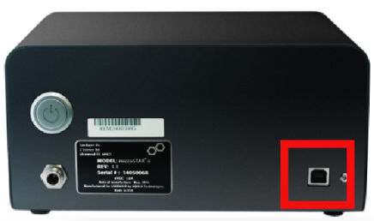
NOTE: The USB cable has two connectors: square (USB Type B) and rectangular (USB Type A).
- Connect the USB Type B connector to the reader USB port.
- Connect the USB Type A connector to any available USB port on the computer.

Verifying Connectivity
Figure 4-3: Reader USB Connection
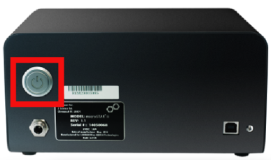
- Turn on the computer.
- Turn on the reader using the Power Button.
The Power LED should illuminate.
Figure 4-4: Reader On Button

Connections Example
The connections for the all-in-one computer will similar to Figure 4-5 below.
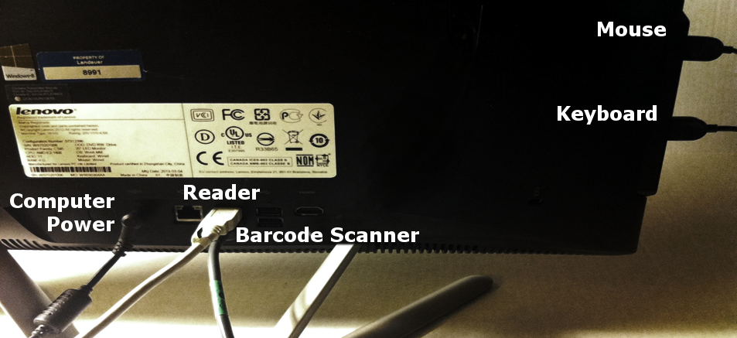
Figure 4-5: All-in-One Fully Connected

Software Configuration
Use the information and instructions in the subsections to configure the software to prepare for system configuration and update system access.
- Logging Into the System (5.1)
- Changing the Default Account Password (5.2)
- Connecting the Reader (5.3)
- Setting Up Unique User Accounts (5.4)
Information Needed
- User Account Information (user names, passwords and profile information for Advanced Operator and other system users)
Note: At a minimum an Advanced Operator account must be created to complete system configuration. Other accounts can be created post-installation.

Logging In
Complete the following steps to log on to the microSTARii system for the first time:

- From the desktop double-click the microSTARii reader application icon to launch the microSTARii Medical Dosimetry System software.
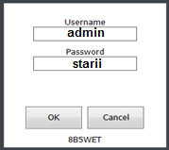
- Log on to the system using the default Administrator logon credentials.
Default microSTARii  Logon Credentials  Figure 5-1: Log On Window | USERNAME: admin
 | PASSWORD: starii

Changing Admin Account Password
To protect system data, the default password must be changed after you have logged in for the first time. To change the default password, complete the steps below:
- Navigate to the Security tab.
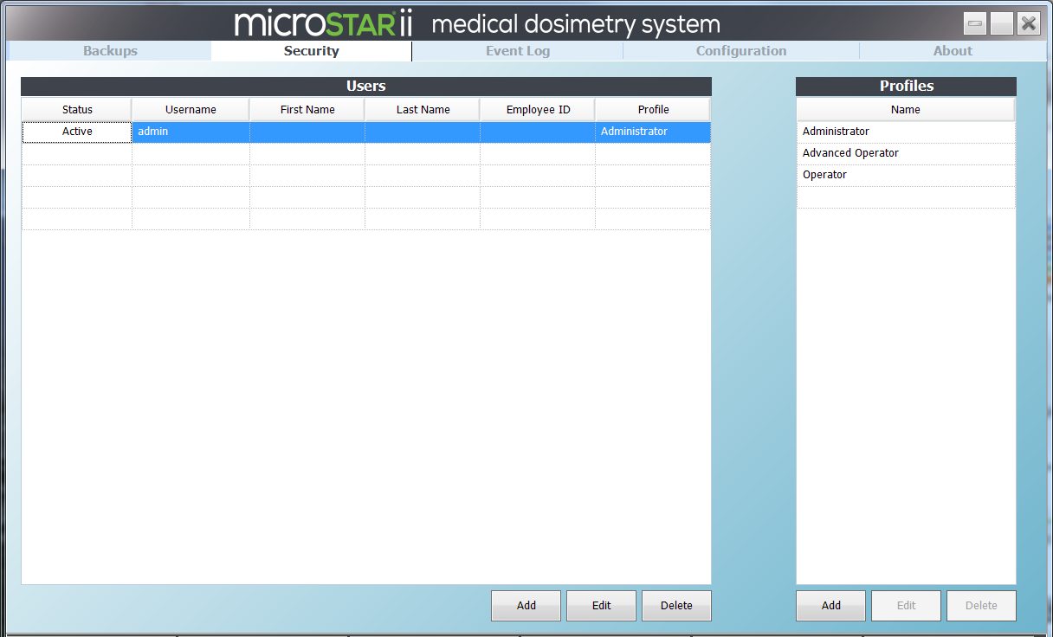
Figure 5-2: Security Tab
- In the Users table, double-click on the admin account row to launch the Edit User window.
OR
Click the row to select it, and click the Edit button to launch the Edit User window.
- Type in a new password, and type it again in the Confirm Password field.
- Click OK to save the new password.
- Log out of the microSTARii application. (Click the [X] on the upper-right of the screen.) Log back on to confirm the password change was successful.

Connecting Reader
After you have logged into the system and changed the default account, complete the following steps to confirm your reader settings and assign a reader name:
- Navigate to the Configuration tab.
- Click the Manage Readers button. (Outlined in Figure 5-3 below.)
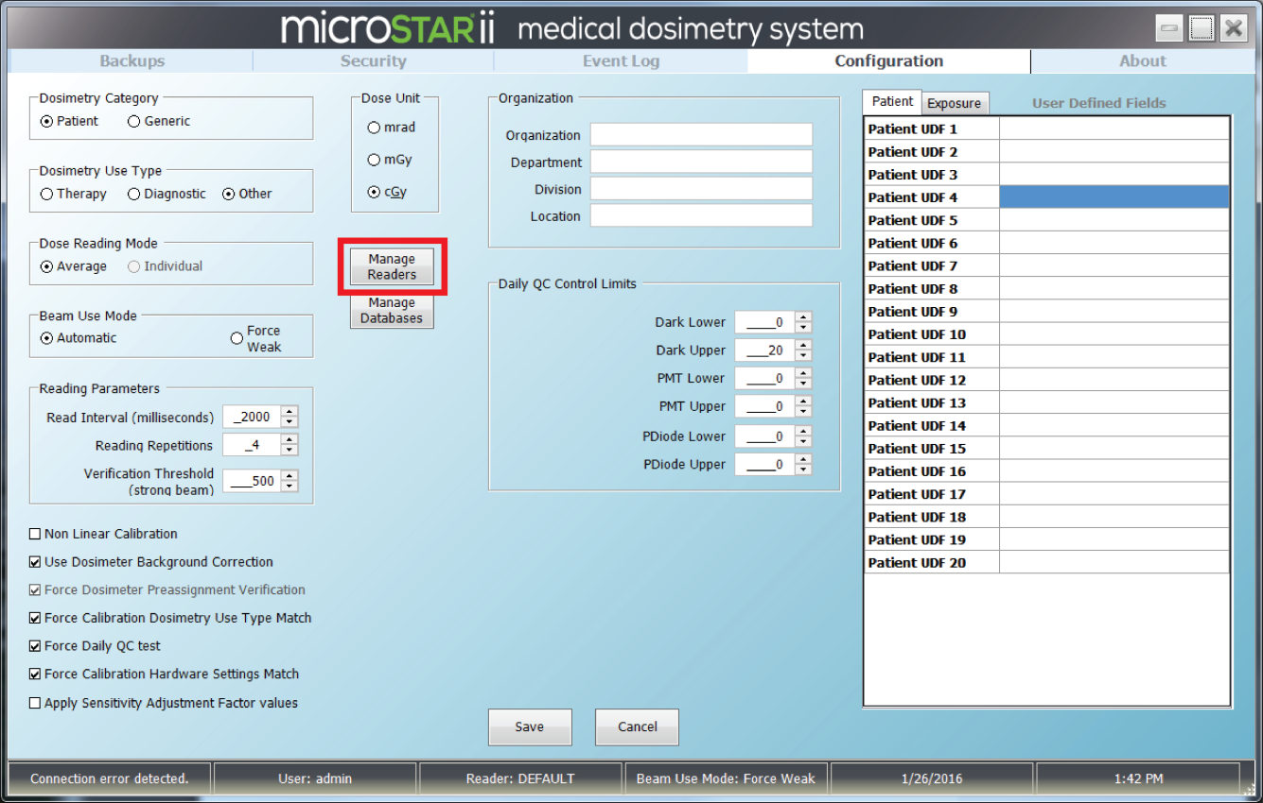
Figure 5-3: Configuration Tab – Manage Readers
- In the Reader Management dialog box, validate that the reader successfully connected by verifying that the DEFAULT reader has the following two values:
- A Reader UID value that corresponds to the last four digits of the serial number on the back of the reader.
- The CurrentHardwareSettingID value is 1.
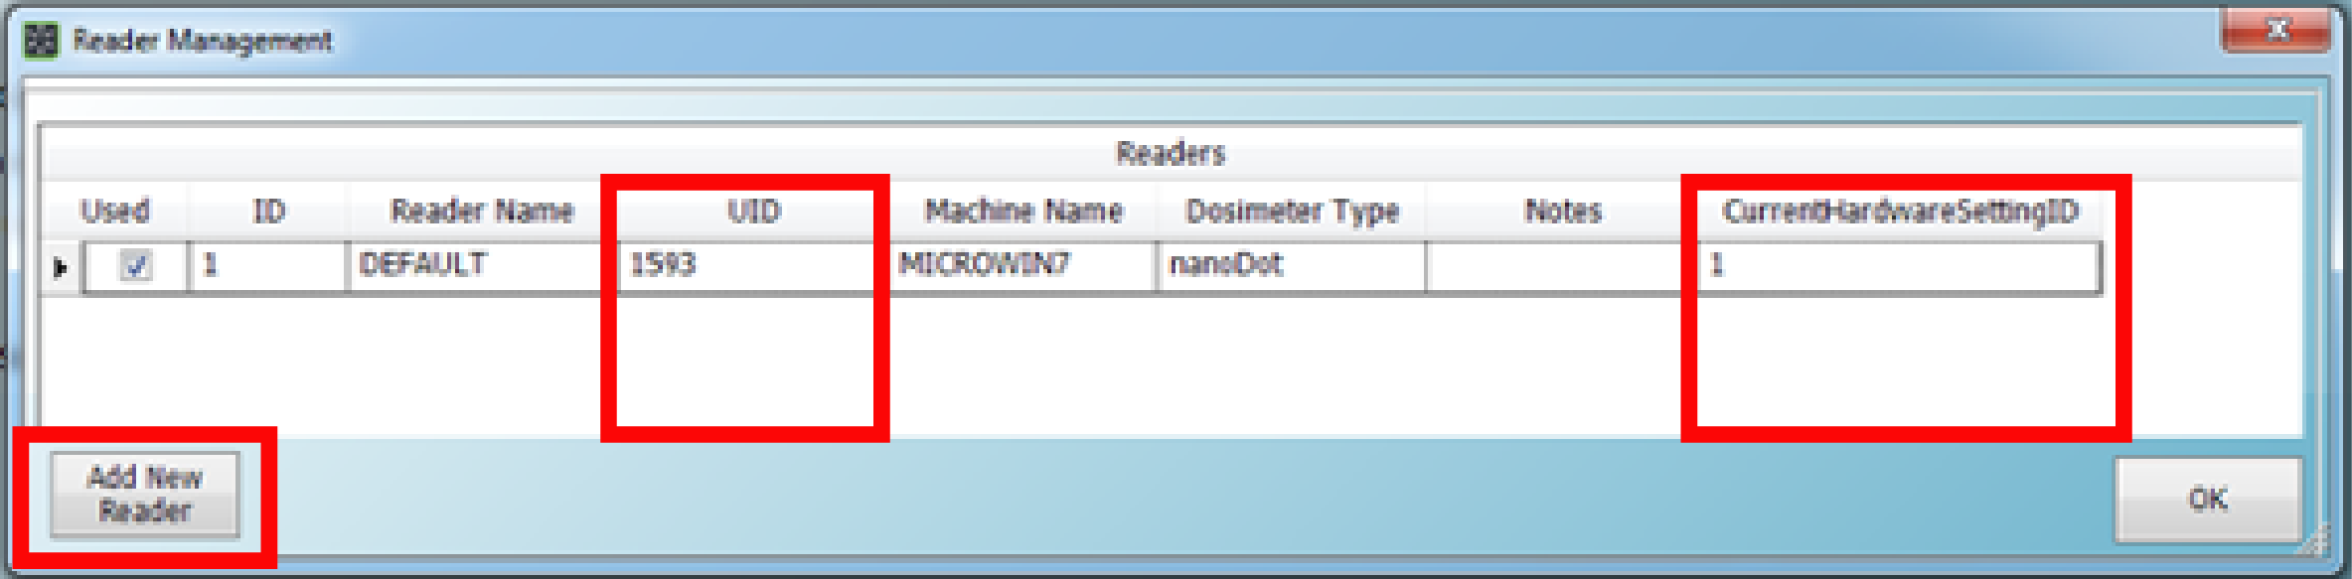
Figure 5-4: Reader Management Dialog Box
- Assign a unique reader name to the reader:
  - Click the Add New Reader button.
  - New Reader dialog box, enter in a unique name for the new reader.
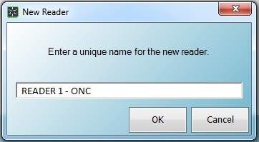
Figure 5-5: New Reader Dialog Box
  - Click OK and the new reader will be listed on the Reader Management window.
- Verify the Used check box is selected next to the new reader entry. Click OK to exit the Reader Management window.

Creating User Accounts
To support compliance with HIPPA guidelines, microSTARii provides the capability to configure unique user accounts. Creating individual user accounts supports security audits and provides traceability.
In addition to individual accounts, microSTARii uses profiles to control user permissions. The system includes three default profiles for common permissions: Administrator, Advanced Operator, and Operator. The following table lists the default profiles and security limitations. For a full listing of permissions see Appendix A: Profile Permissions Listing.
Profile | User Type | Restrictions
Administrator | Administration | - Cannot operate reader  - Cannot modify reader factory hardware settings
Advanced Operator | Expert Level | - Cannot create user accounts  - Cannot access advanced configuration settings  - Cannot modify reader factory hardware settings
Operator | Routine Dosimetry | - Cannot access most configuration settings  - Cannot access certain advanced features such as Sensitivity Assessment  - Cannot modify reader factory hardware settings
Accounts and profiles are managed on the Security tab (Figure 5-2).
NOTE: The admin account cannot be used to operate the reader for dosimetry measurements. At a minimum, you must set up an account using the Advanced Operator profile to complete the configuration in Chapter 7 Testing & Calibration.
It is recommended that a system administrator account is created using the Advanced Operator profile to allow the administrator to verify reader configuration and performance during operations.
Complete the following steps to add a new Advanced Operator user account.
- On the Security tab (Figure 5-2), click the Add button under the Users table.
- Fill in the fields in the dialog box (Figure 5-6).
  - Username
  - Password (must be greater than four characters, with no spaces)
  - Confirm Password
  - Profile (select Advanced Operator)
  - Employee ID
  - First Name
  - Last Name
  - Active (Y/N Check Box)
  - Notes (optional)
Note: Fields a-d are required.
- Click OK to add the user.
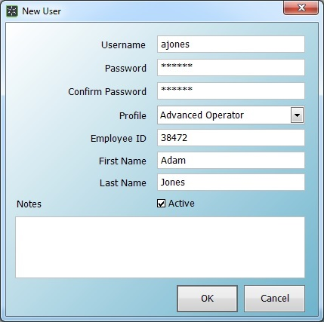
Figure 5-6: New User Form
- Repeat steps to set up additional user accounts. (Change value in Step 2.d. for other profiles.)
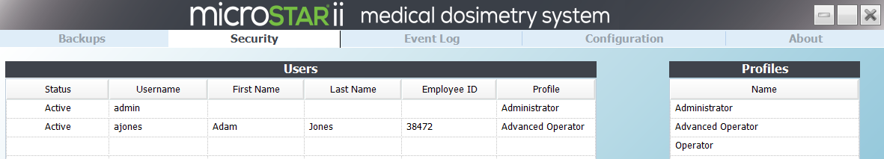
Figure 5-7: Updated User Account Listing

System Configuration
Use the information in this chapter to configure the system for reporting and dosimetry measurements.
- Organization Information
- Beam Use Mode
- Verification Threshold
Information Needed
- Factory Test Result Sheet
NOTES:
The system configuration outlined in this section should be completed using the admin account.
All configuration outlined in this chapter is completed on the Configuration tab.
To apply changes, click the Save button at the bottom of the screen.
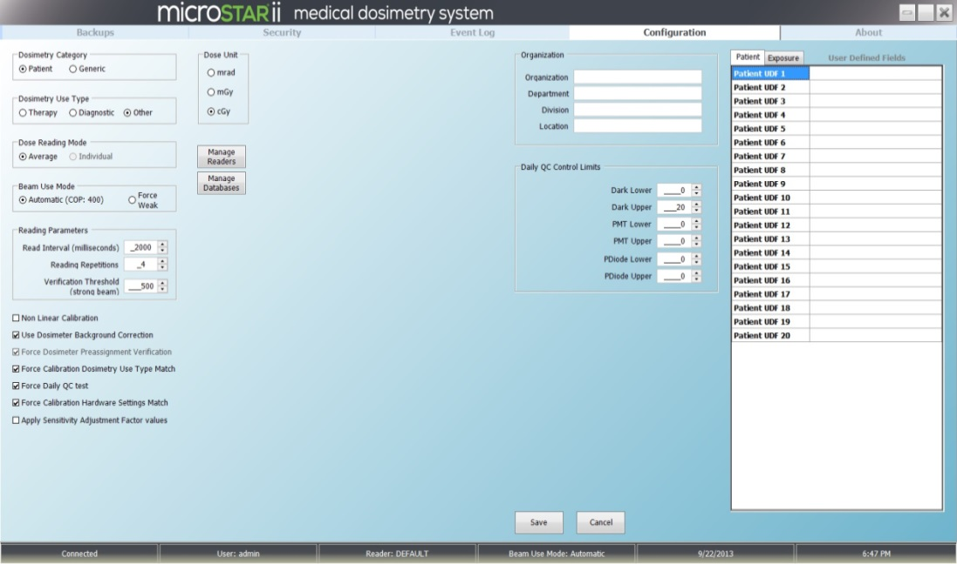
Figure 6-1: Configuration Tab
Use the information in the following table to configure the system.
NOTE: The Daily QC Control Limits fields are updated based on the results of the configuration tests run in section 7.1.1. Other values on the configuration screen can be modified based on usage and operational needs.
Field | Description | Configuration
Organization | This information is used in dosimetry reports (i.e., the Patient Dose Report) and associated database records.  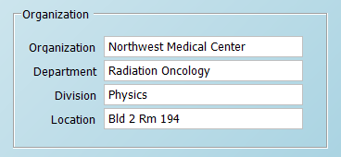 | Fill in the following fields:  - Organization Name  - Department  - Division  - Location
Beam Use Mode | This setting determines whether the reader switches between strong and weak LED levels (Automatic) or uses only the LED level regardless of dose level (Force Weak). In most applications, automatic mode is used. Force Weak is used in non-linear calibrations for high doses.  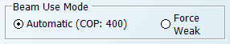 | - Verify the Automatic option is selected.  - Validate that the COP value matches the Factory Test Results sheet.
Reading Parameters (Verification Threshold) | This setting is the limit for the dosimeter pre-assignment test.  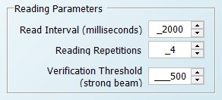 | The default and recommended value for nanoDots read using the strong beam mode is 500 raw counts. The value can be lowered for very low dose applications to reduce the acceptable limit.  NOTE:  Unexposed dosimeters that have been manufactured within the last six months prior to verification, typically yield strong beam raw count values below 200.

Testing & Calibration
Performance testing and reader calibration must be completed in order to prepare the system for use. Use the information in this chapter to prepare the system for reporting and dosimetry measurements.
Performance Testing
The built-in performance testing assesses the stability of the reader electronics, photomultiplier tube (PMT), and LED.
- Establish Intrinsic Test Control Limits (Reader QC Test) (7.1.1)
- Perform Intrinsic Test (Reader Daily QC Test) (7.1.2)
- Perform nanoDot Reading Reproducibility Test (7.1.2)
Reader Calibration
Reader calibration uses the LANDAUER-provided calset and QC set of dosimeters to create the calculations needed to verify the reader performance and set a baseline for 80 kVp, Cs137, or Non-Standard exposure conditions.
- Perform Reader Calibration (7.2.1)
- Perform Post-Calibration Quality Control Check (7.2.2)
Equipment Needed
- NIST-Traceable 80 kVp, Cs137, or Non-Standard Calset
- NIST-Traceable 80 kVp, Cs137, or Non-Standard Post-Calibration QC Set
- 1 Consistency nanoDot
As part of this step of configuration, you will need to handle the nanoDot. While the nanoDot can fit in the tray in various positions, for the nanoDot to be properly read and the drawer to close, the nanoDot must be put in the tray well with the barcode facing up and at the upper-left corner. The nanoDot must be sitting flat in the tray. If the drawer does not easily close, do not try to force it to close.
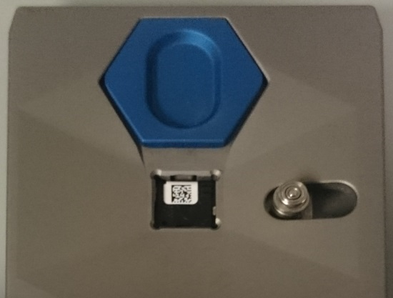
Figure 7-1: Correct nanoDot Orientation
WARNING: If the nanoDot is incorrectly positioned in the reader drawer (e.g., not set in completely or put in with barcode facing down) the reader and nanoDot may be significantly damaged.
To eject the nanoDot, pull the blue ejector toward the nanoDot.
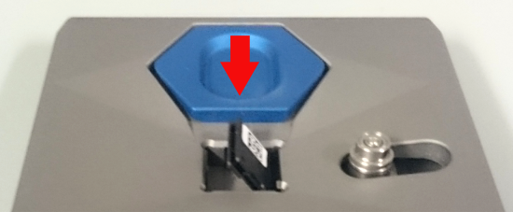
Figure 2: Ejected nanoDot

NOTES:
The system configuration and testing outlined in this section should be completed using an Advanced Operator account.
The reader should be turned on for at least 60 minutes with a connected device status. (Status is the first value listed on the bottom bar of the microSTARii application window.)

Performance Testing
The performance testing is conducted on the QA tab.
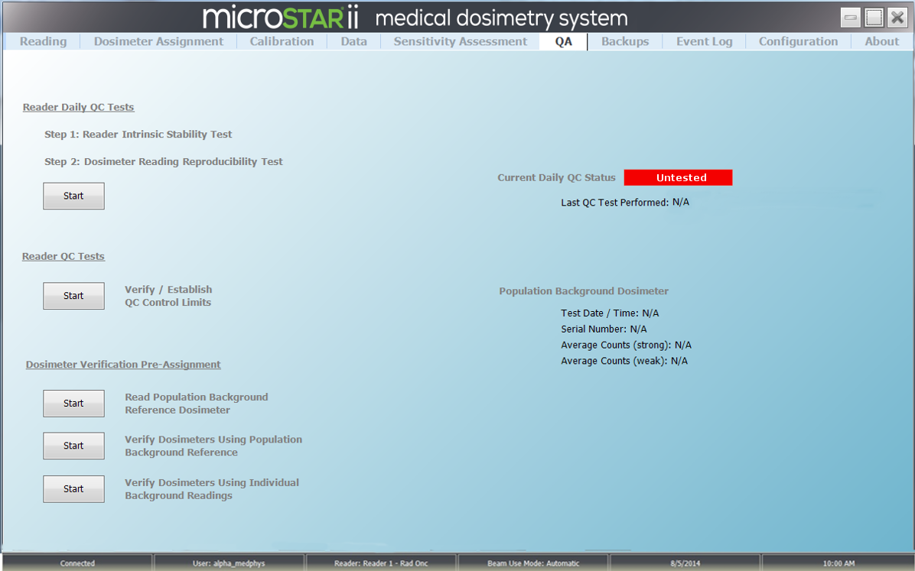
Figure 7-3: QA Screen – Untested
NOTE: The results for all tests run in this chapter can be found in the microSTARii system directory: C:\ProgramFiles\LandauerInc\microSTARiiReader\Reports. The reports are generated in PDF, XLS, and XML formats. See Appendix B: QC Report Examples for example reports.
It is recommended that you maintain all QC record data in either electronic or hardcopy format, for the life of the reader.

Intrinsic Test: Reader QC Test
Complete the following steps to establish QC Control Limits for the system:
- On the QA tab, click Verify/Establish QC Control Limits Start button.
- A High precision intrinsic measurement test prompt will appear. Confirm there is no dosimeter in the reader and that the door is closed.
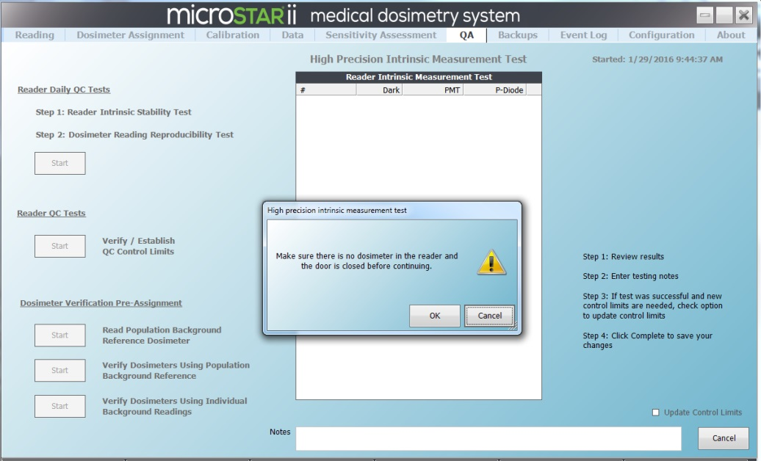
Figure 7-4: Verify/Establish QC Control Limits
- After 20 cycles of measurements have been completed, the report will be updated with a colored bar reflecting the test result (green for a passed test, red for a failure). Click OK on the test results dialog box.
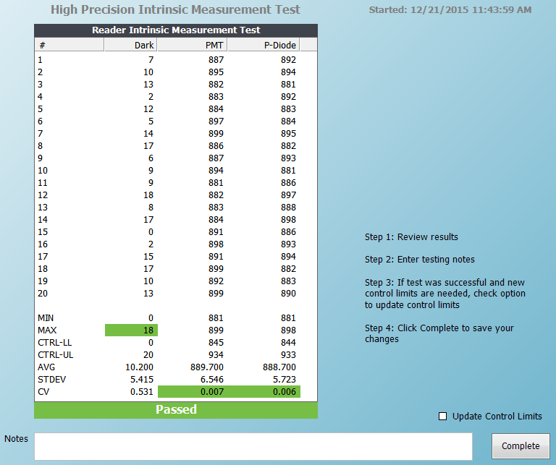
Figure 7-5: Reader QC Tests – Passed
- Select the Update Control Limits check box.
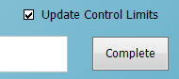
Figure 7-6: Update Control Limits Option
- Click the Complete button to save and exit the test.
- Navigate to the Configuration tab, and confirm the values have updated.
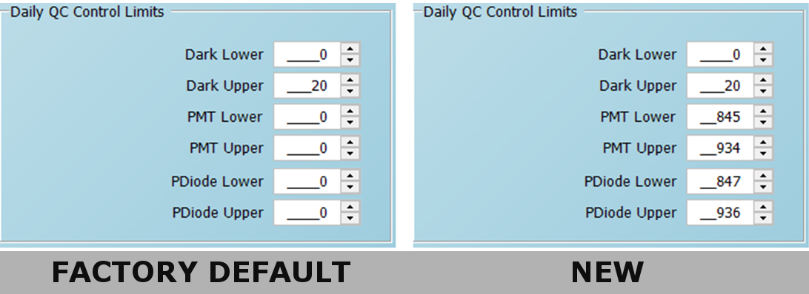
Figure 7-7: Daily QC Control Limits Update Example

Reader Daily QC Test
Equipment Needed
- 1 High-Dose Consistency nanoDot
After the Verify/Establish Control Limits process has been completed, complete the following steps to run the Reader Daily QC Tests. This test is divided into two parts: Intrinsic Measurement and Reading Reproducibility. They are automatically run in sequence after the Start button is pressed.
- On the QA tab, click the Start button under Reader Daily QC Tests. The Reader Intrinsic Measurement Test will start.
- A Daily QC Test Step 1 prompt will appear. Confirm there is no dosimeter in the reader and that the door is closed.
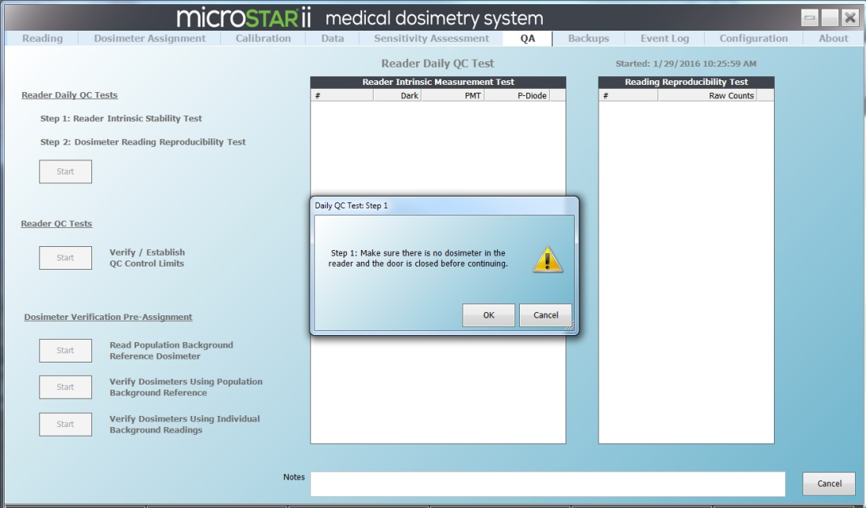
Figure 7-8: Reader Daily QC Test – Start
- When the first test is complete, click OK on the Reader Daily QC Test results prompt. The report will be updated with a colored bar reflecting the test results. The test will move on to the next step if the test is passed.
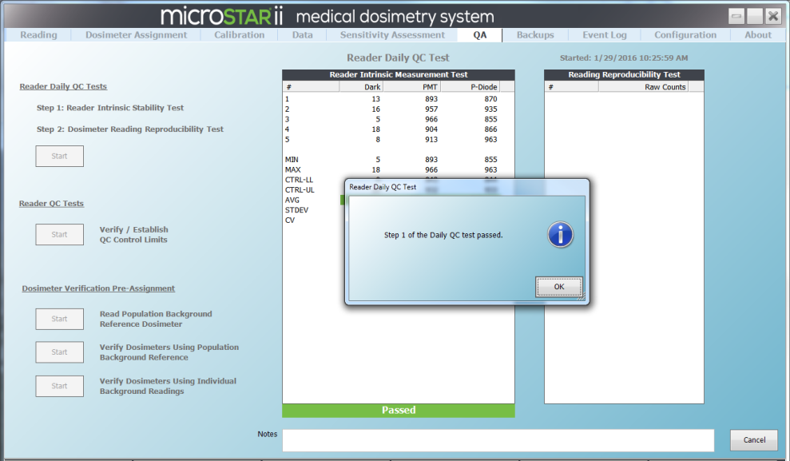
Figure 7-9: Reader Daily QC Test – Step 1 Passed
- In the Daily QC Test: Step 2 prompt, enter the serial number or scan the barcode for a high-dose consistency nanoDot.
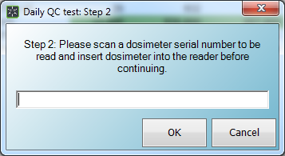
Figure 7-10: Reader Daily QC Test – Consistency nanoDot Entry
- Place the consistency nanoDot in the reader drawer with the barcode facing up. Ensure the nanoDot is sitting flat. Close the drawer completely. (Figure 7-1)
- Click OK to start the Reading Reproducibility Test. Ten readings will be completed and the coefficient variation (CV) will be computed.
- When the test is complete, click OK on the Reader Daily QC Test results prompt. The report will be updated with a colored bar reflecting the test results. If the CV is ≤ 1.0% the test will pass.
- Click OK on the Test Passed notification, and click the Complete button to save and exit the test.
- The Current Daily QC Status on the QA tab should now be listed with a status of Passed.
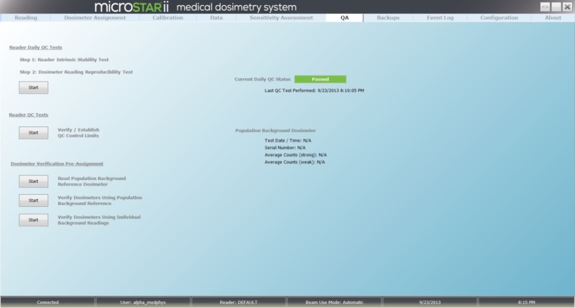
Figure 7-11: QA Tab — Daily QC Passed

Reader Calibration
After the performance tests are completed, the system can be calibrated using dosimeters with known doses to determine the calibration factors used to convert the raw PMT count to dose.
NOTE: microSTARii has four default calibrations included (two Linear and two Non-Linear), Factory Default Calib. These are not for clinical use. They are database placeholders.

Initial Calibration
Equipment Needed
- NIST-Traceable 80 kVp, Cs137, or Non-Standard Calset (Therapy)
Complete the following steps to calibrate the reader using the LANDAUER-provided calset:
- On the Configuration tab, confirm the following settings:
- Beam Use Mode: Automatic
- Dose Unit: mrad
- From the Calibration tab, enter a Process ID.
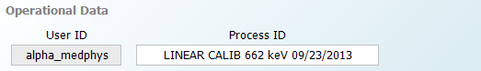
Figure 7-12: Calibration Screen Operational Data Example
- Sort the calset in dose order.
- Complete the following steps for each dosimeter:
- Click in the Dosimeter # field. Scan an unread dosimeter from the set or enter the serial number into the Dosimeter # field. The Sensitivity field will automatically update. (It should match the number printed on the top of the nanoDot, DN###.)
- Fill in Exposed Dose Field using the SDE value on the LANDAUER Calibration Certificate. For unexposed dosimeters enter 0.0.
- Enter 4 for the Number of Reads value.
- Place the nanoDot in the reader drawer with the barcode facing up. Ensure the nanoDot is sitting flat. Close the drawer completely. (Figure 7-1)
- Click the Read button to run a series readings.
- Repeat steps a-e for each dosimeter in the calset.
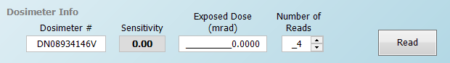
Figure 7-13: Dosimeter Info Field
- After all dosimeters have been read, review all of the calibration data to ensure the displayed dose levels are correct and reflected in the correct dose units. If necessary, omit any inconsistent or outlier readings by unselecting the Used check box for that result. Verify that the coefficient of variation (CV) across all sensitivity-corrected counts for each dose level within acceptable limits (≤ 0.05), and that for a specific dose range, that only doses corresponding to that dose range are included in the calibration data group.
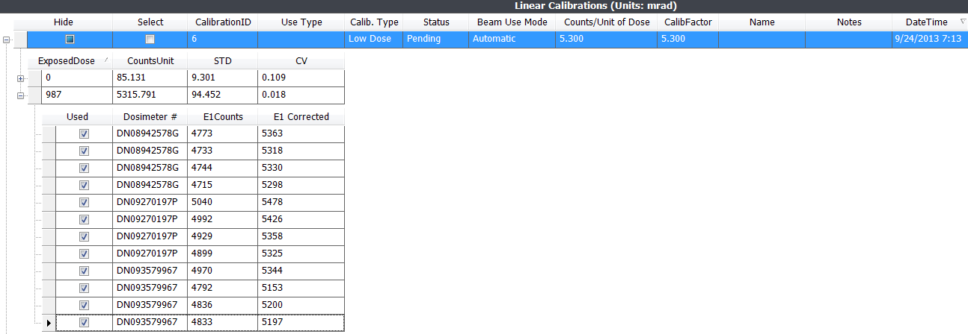
Figure 7-14: Calibration Detail (Showing Acceptable CV)
- For each new calibration, select the Pending calibration, and click the Accept button.
- Fill in the values on the Calibration dialog box, and click OK to confirm.
  - Cs-137 Calibration Use Type: Other
  - 80 kVp Calibration Use Type: Diagnostic
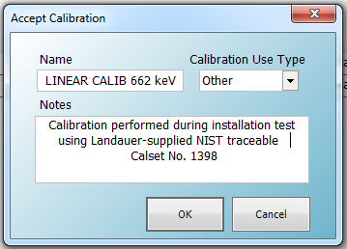
Figure 7-15: Accept Calibration Dialog Box
- After completing a calibration for both the low and high dose ranges, ensure both are listed on the Calibration tab and are selected. Click Save the Selection at the bottom of the screen.
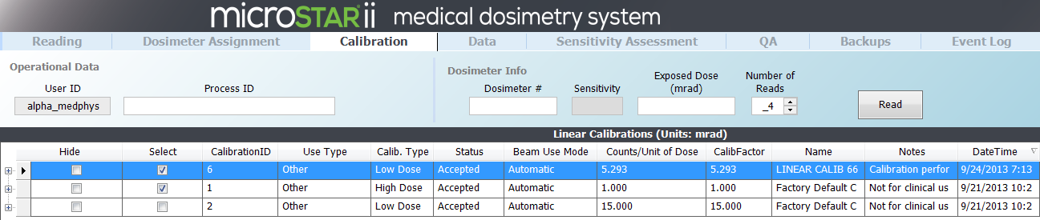
Figure 7-16: Completed Low Dose Calibration

Post-Calibration Quality Control Check
Equipment Needed
- NIST-Traceable 80 kVp, Cs137, or Non-Standard Post-Calibration QC Set
After the system has been calibrated using the LANDAUER calset, complete the following steps to validate the calibration:
- On the Configuration tab, confirm the following settings are configured.
Configuration Setting | Configuration Value
Dosimetry Category | Generic
Dosimetry Use Type | Other
Dose Reading Mode | Average
Beam Use Mode | Automatic
Dose Unit | mrad
Reading Repetitions | 4
Force Calibration Hardware Settings Match | Selected
Other Checkboxes | Unselected
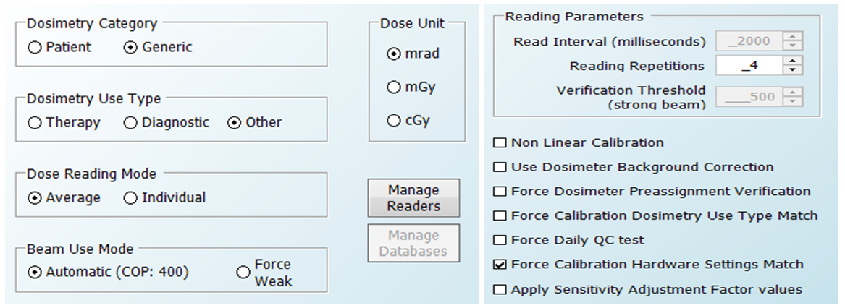
Figure 7-17: Configuration Settings
- On the Reading tab, enter a unique Process ID (e.g., Post Cal QC).
- Click to put the cursor in the Dosimeter # field. Scan the dosimeter or enter the serial number.
- On the New Dosimeter dialog box (Is this a screened nanoDot?), click Yes to confirm.
- On the Process ID does not exist prompt, click Yes to confirm the new Process ID.
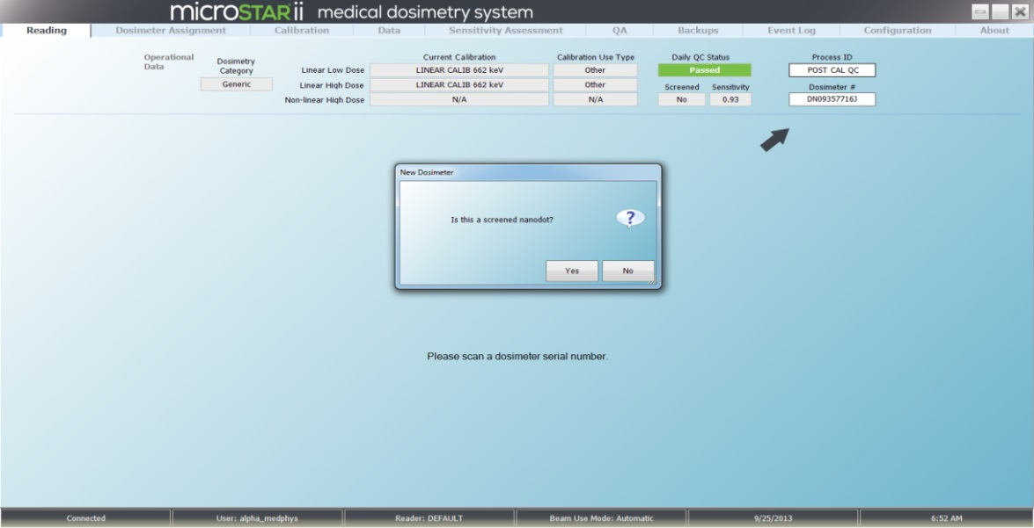
Figure 7-18: Reading Tab with QC nanoDot Settings
- Place the nanoDot in the reader drawer with the barcode facing up. Ensure the nanoDot is sitting flat. Close the drawer completely. (Figure 7-1)
- Click Read. The nanoDot will be read four times and the computed dosimetry results will display on the screen.
- Verify the computed dose is within ±5.5% of the known exposed dose listed on the LANDAUER certificate.
- Repeat Steps 3-8 for all dosimeters in the QC Set.
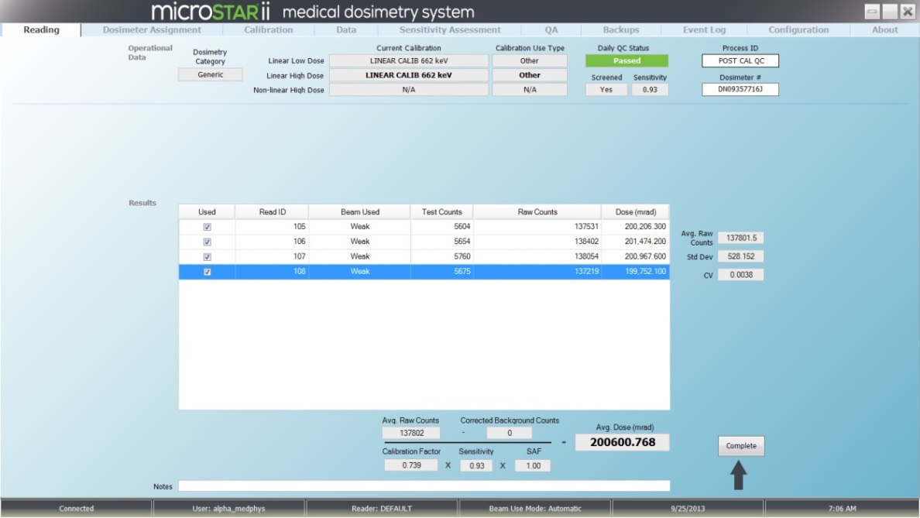
Figure 7-19: QC Set Reading Results

Custom Calibration
LANDAUER-manufactured calsets provide a baseline for 80 kVp, Cs137, or Non-Standard exposure conditions. These calsets are used to validate system performance.
After the initial calibration is completed, create a custom calset to mirror the conditions in your facility. To create a custom calset, irradiate screened nanoDots using the exposure conditions in your environment. Perform the calibration procedure outlined in section Chapter 7 using the custom calset. (Note: The Dose Unit configuration value may change based on exposure conditions.)
The following table provides a guideline for custom calsets exposure levels.
Recommended Custom Calset Exposure
Doses in cGy
Linear Calibration (Beam Use Mode: Automatic)
Low Dose Linear Range (<15 cGy) | unexposed, 5 cGy, 10cGy
High Dose Linear Range (>15 cGy) | 50, 100, 200 cGy
Linear Calibration (Beam Use Mode: Force Weak)
High Dose Linear Range (>1cGy) | 10, 50, 100, 200 cGy
Non-Linear Calibration
High Dose Non-Linear Range (300-1300 cGy) | 50, 100, 300, 500, 800, 1000, 1300 cGy
Note: The benefits of the Linear calibration using force weak mode are that you only have to perform a single calibration and the reader will be operated using the weak beam, which is associated with lower depletion rates.

Troubleshooting
If you receive error messages or need further assistance, contact LANDAUER Technical Support.

Technical Support
Address | LANDAUER Customer Service  2 Science Rd. Glenwood, IL 60425
Telephone | 800-561-2708
Email | inlightcustserv@landauerinc.com
Operating Hours | Monday–Friday: 8:00 am to 4:30 pm Central Time
When calling LANDAUER, please provide the representative with the following information:
- Your contact Information (Name, Phone #, Email Address, and Organization/Facility)
- Type of Call (Informational or System Failure)
- Severity of Issue
- Device Status (Operational or System Down)
- Type of Issue (Hardware/Software)
- Reader Serial # (see back of reader)
- Software Version (see the About tab)
- Approximate Age of System
Please provide additional specific details of your hardware or software failure (if available):
- Operator User Name & Permissions Level (Administrator, Advanced Operator or Operator)
- System Warnings or Symptoms Encountered Prior to Issue
- Screenshot of Software Issue/Message
- Picture of Hardware Issue/Failure
- Event Logs
- Profile Permissions Listing
Category | Permission | Operator | Advanced Operator | Administrator
Backup | Screen: Backup
Backup | Groupbox: Reset Database
Backup | Button: Backup
Backup | Button: Restore
Backup | Button: Delete
Backup | Checkbox: Automatic Daily Backup
Calibration | Screen: Calibration
Calibration | Groupbox: Operational Data
Calibration | Groupbox: Dosimeter Info
Calibration | Grid: Calibrations
Calibration | Button: Save
Calibration | Button: Hide
Calibration | Button: Show All
Calibration | Button: Edit Correction Factors
Calibration | Button: Edit Control Dose
Calibration | Button: Accept
Calibration | Button: Reject
Configuration | Screen: Configuration
Configuration | Checkbox: Apply Sensitivity Adjustment Factor Value
Configuration | Checkbox: User Dosimeter Background Correction
Configuration | Checkbox: Non Linear Calibration
Configuration | Groupbox: Display Unit
Configuration | Groupbox: Beam Use Mode
Configuration | Button: Reader Management
Configuration | Button: Database Management
Configuration | Button: Add New Reader
Configuration | Groupbox: Daily QC Control Limits
Configuration | Groupbox: Organization
Configuration | Checkbox: Force Calibration Dosimetry Use Type Match
Configuration | Checkbox: Force Dosimeter Preassignment Verification
Configuration | Checkbox: Force Daily QC
Configuration | Groupbox: User Defined Fields
Configuration | Textbox: Read Interval
Configuration | Groupbox: Dosimetry Category
Configuration | Groupbox: Dosimetry Use Type
Configuration | Groupbox: Dose Reading Mode
Configuration | Textbox: Reading Repetitions
Configuration | Textbox: Verification Threshold
Configuration | Checkbox: Force Calibration Hardware Settings Match
Configuration | Textbox: Reader Serial Number
Configuration | Textbox: Reader Notes
Data | Screen: Data
Data | Groupbox: Templates
Data | Button: Export
Dosimeter Assignment | Screen: Dosimeter Assignment
Dosimeter Assignment | Button: Export Worklist
Dosimeter Assignment | Button: Add Patient
Dosimeter Assignment | Button: Edit Patient
Dosimeter Assignment | Button: Delete Patient
Dosimeter Assignment | Button: Edit Assignment
Dosimeter Assignment | Button: Remove Assignment
Dosimeter Assignment | Textbox: Serial Number
Event Log | Screen: Event Log
QA | Screen: QA
Reading | Screen: Reading
Reading | Button: Patient Details
Reading | Button: Assignment Details
Security: | Screen: Security
Sensitivity Assessment | Screen: Sensitivity Assessment
Sensitivity Assessment | Sensitivity Adjustment Factors ->Edit SAF
- QC Report Examples
Reader QC Test Example Report
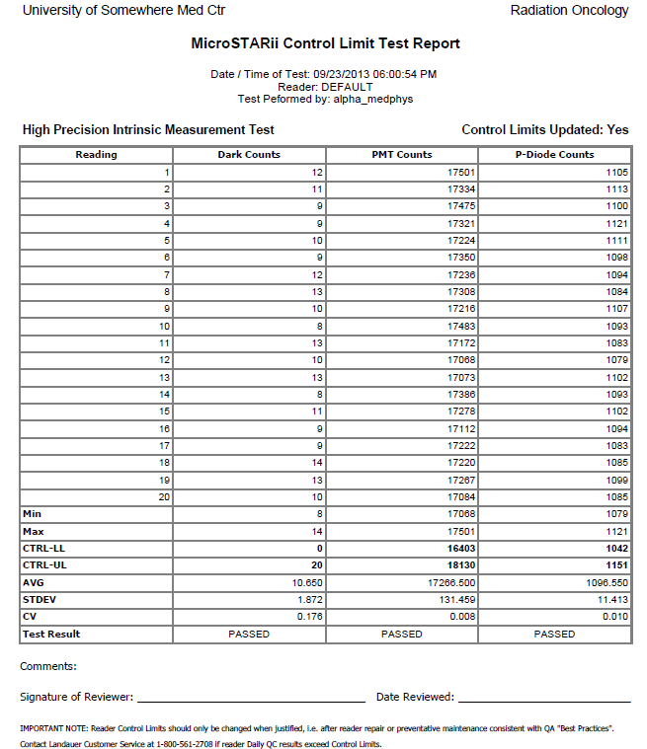
Reader Daily QC Test Example Report
